NAME: KHEW XAVIER ETHAN

ID: 1181202757

ACCOUNT REGISTRATION

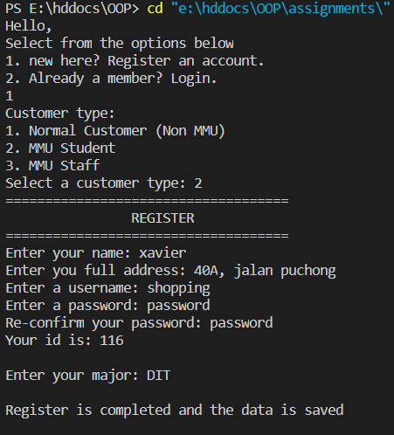

ACCOUNT LOGIN (FAILED)

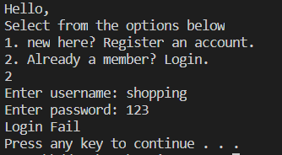

ACCOUNT LOGIN (SUCCESS)

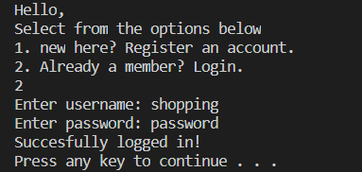

ACCOUNT LOGIN (SUCCESS, AFTER CLICK ANY KEY)

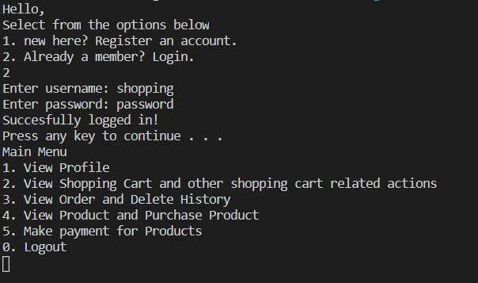

VIEW USER PROFILE WITH NO PROFILE DELETE

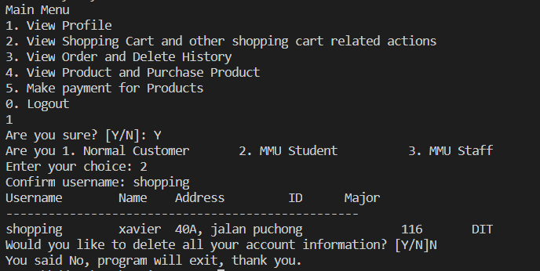

ENTER PRODUCT INTO SHOPPING CART(MOVIE)

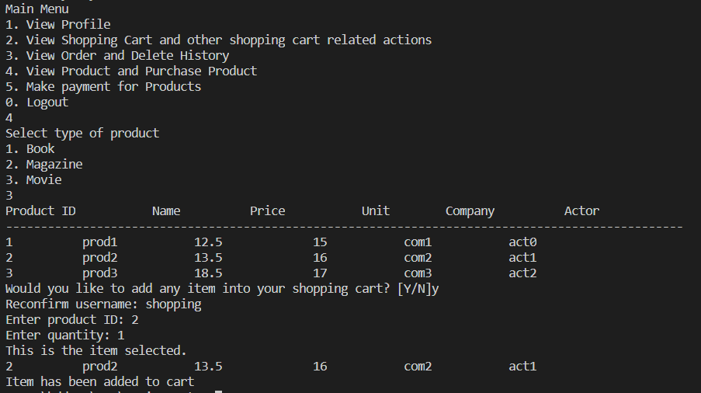

DELETE SHOPPING ITEM FROM SHOPPING CART

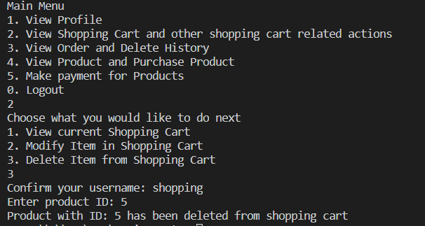

MAKE PAYMENT

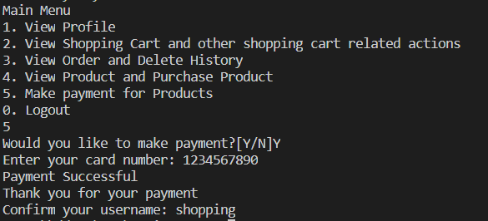

VIEW SHOPPING CART HISTORY (EMPTY NOW AS THERE HAS BEEN NO TRANSACTIONS)

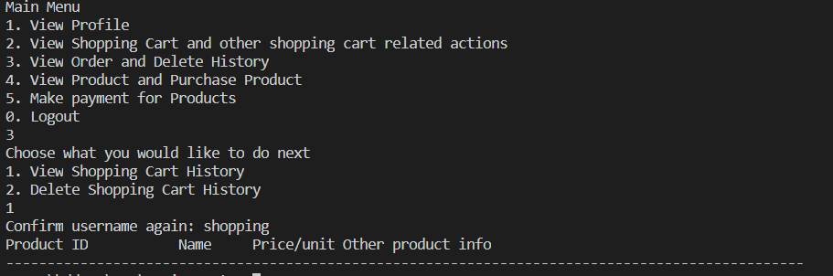

LOGGED OUT

